**Joachim, Otto (1910-2010)**

Jeremy Strachan

Composer, violist, painter, and instrument builder born at Düsseldorf and died at Montreal, Canada. Joachim fled Germany in 1934 and spent fifteen years as a stateless person in Singapore and China, before emigrating to Montreal in 1949. There he taught at McGill University and the Conservatoire de Montreal, formed the Montreal Consort of Ancient Instruments (1958-69), and became principal violist of the Montreal Symphony Orchestra. By 1956 he established his own fully functional electroacoustic music studio. Early compositions such as *ASIA* (symphonic poem, 1929-39) predate explorations in a melodic and idiomatic dodecaphonic style developed in the 1940s and 50s (*L’ECLOSION* for solo piano, 1954; and *CONCERTANTE No. 1*, 1955-7). Throughout the 1960s Joachim experimented with aleatory, graphic notation, and mixed media in works that balanced electronic, acoustic, and theatrical elements. *KATIMAVIK* (four channel tape, 1967) was commissioned for Canada’s centennial celebrations, and mirrored in structure the architecture of the Canadian pavilion at Expo ’67 in Montreal; *ILLUMINATIONS I* (1965) employs serial and aleatoric techniques in exploring relationships between light and sound. Joachim received the Grand-Prix Paul Gilson for *ILLUMINATIONS II* (1969), an honourary doctorate from Concordia University (1994), and was made Chevalier de l’Ordre National de Québec (1993).

**Selected Works**

*ASIA*, 1929-39

*L’ECLOSION*, 1954

*CONCERTANTE No. 1*, 1955-7

*STRING QUARTET*, 1956

*ILLUMINATIONS I*, 1965

*KATIMAVIK*, 1967

*CONTRASTES*, 1967

*ILLUMINATIONS II*, 1969

*MANKIND*, 1972

*STACHELDRAHT*, 1994

**Photo**

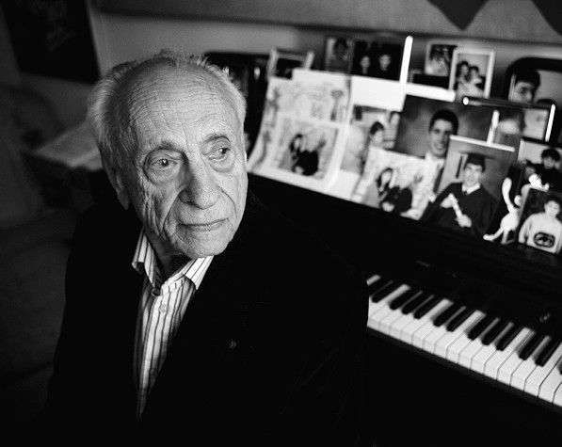

Source: <http://glenngould.ca/storage/post-images/otto%20joachim.jpg?__SQUARESPACE_CACHEVERSION=1281915475958>

**Links**

Joachim’s composer profile page on the Canadian Music Centre:

<http://www.musiccentre.ca/apps/index.cfm?fuseaction=composer.FA_dsp_biography&authpeopleid=494&by=J>

An educational profile of Joachim’s cultural influences, featuring interview excerpts: <http://www.musiccentre.ca/influences/composer.cfm?authpeopleid=494&themeid=2>

**References**

(1964) *Thirty-Four Biographies of Canadian Composers*,Toronto: Canadian Broadcasting Corporation International Service. (A brief bilingual overview of Joachim detailing the early part of his career is included.)

Beckwith, J. and MacMillan, K. (eds.) (1975) *Contemporary Canadian Composers*, Toronto: Oxford. (Extensive entry on Joachim, exploring in detail his work, life, and contributions to modernist composition in Canada.)

Kasemets, U. (ed.) (1967) *Canavangard: Music of the 1960s and After*, Toronto: Berandol. (A curated series of graphic scores, of which Joachim was a part. This catalogue features a brief letter, score excerpt, and list of performances of significant works.)

Pearson, T. et al (1982) “Otto Joachim” *Musicworks* 18. (An informal interview with the composer at his Montreal home.)